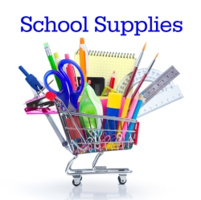

**Winterset Elementary**

**2023-2024 Supply List**

**Intermediate Specialized Learning Center**

* Pencils- 24 (twenty four) #2
* 2 pink erasers
* 24 crayons (Crayola)
* 8 glue sticks
* Scissors
* Set of headphones for computer use
* 4 boxes Kleenex
* 3 SOLID colored 2 pocket folders (with nothing written on them)
* 2 packages of antibacterial wipes (such as Lysol, etc.)
* A complete change of clothes to keep at school